|  |  |
| --- | --- |
| Exercise 2 | if/else |

In this case you are required to make the application accept input and validate the input, if the input is odd or even number then output a message and the input should be Integer.

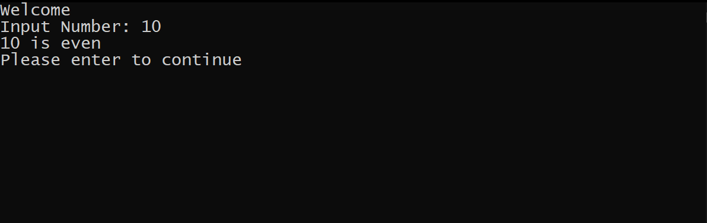

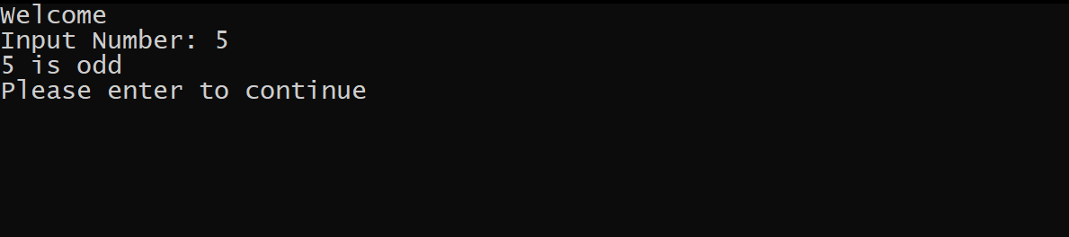

Validate the input if it’s not integer then output a message

